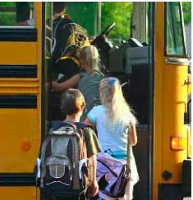 Hello from Canterbury Public Schools
August 2016
Our first day of school is August 29. The administration, custodians, and secretaries work through the summer. Teachers and paraeducators come back on August 25 to attend Convocation. We educators are so lucky…we are in a profession where we get a new start every year; we get to start over; new students, newly painted classrooms, fresh wax on the floors, new school supplies waiting for us, then the doors open and the children come bounding in. Some with smiles, some with tears, and others full of fear. But after just a few minutes, all emotions are quelled and sheer joy erupts. We thank you for your unswerving support of our educational system. Regarding district news, we have redesigned our school website at www.canterburypublicschools.org . We hope this will be the door to closer communication for all. The website is very user friendly and has loads of information to peruse. At BMS, parents may notice a new fence in the parking lot, opening up parking at the far end of the building. Another big summer project was the tennis courts. Due to the poor condition of them, we had to tear them down. A big thank you goes out to the town for working closely with us on this project. The Lion’s Club plaque will be rededicated in the future. After two years of planning and engineering, the solar panels at Canterbury Public Schools are finally being installed. This project should be completed by the end of August and we should “flip the switch” on our Solar savings soon after that. The pictures below show our progress.

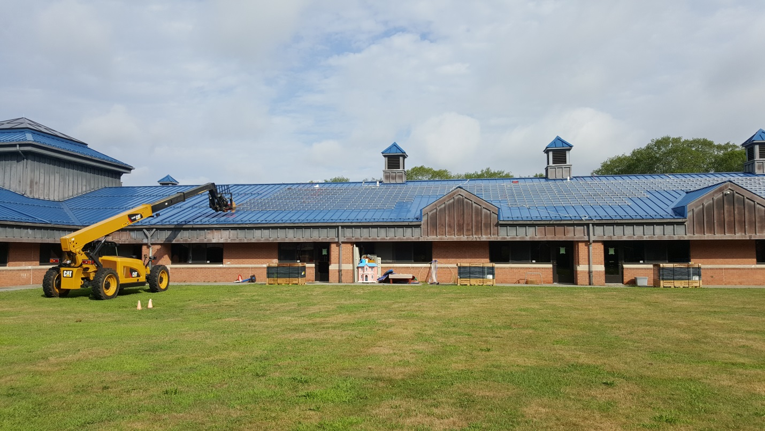
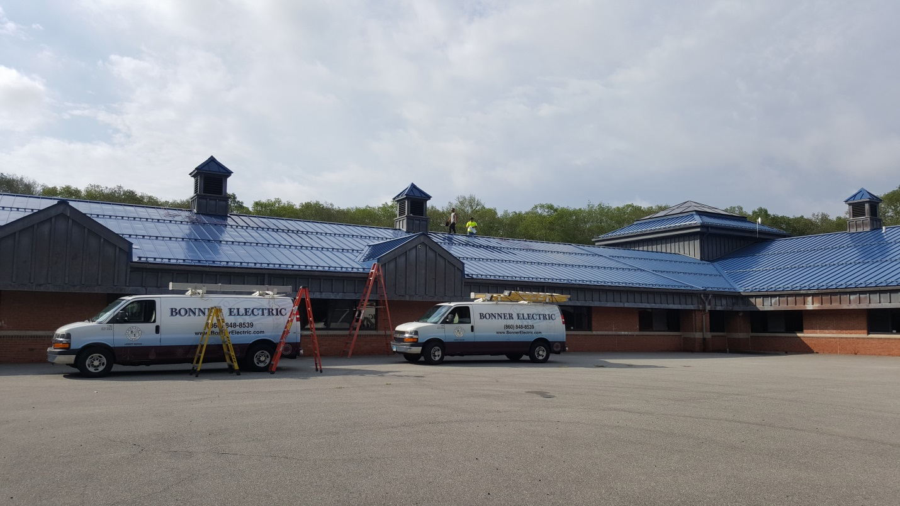

The Special Education Department has enjoyed a wonderful end to the school year with many of our students graduating from area high schools, as well as, some moving on to transition programs for 18-21 year olds. We are very proud of all that they have achieved! Our younger students have also been busy and enjoyed extended school year programs at both CES and BMS, as well as, across our region. One such program that many students experience is at Camp Quinebaug. Camp “Q” is run by the State of CT Department of Developmental Services. It is a Camp located in Killingly, CT for school age children with special needs. Fun summer activities, including boating and swimming, are offered at no cost to families. In order to maintain staff and resources at Camp Q, fundraising is very important. If you are interested in learning more about Camp Quinebaug you may find information at http://www.campquinebaug.com/.
The Baldwin Middle School finished up a wonderfully successful school year with the culminating event being the Eighth Grade recognition ceremony returning to Canterbury. The evening was highlighted with recognition of scholarship and citizenship. The community support for the students was amazing with coordination of personalized and memorial awards all the way to traffic flow and transportation. Students and guests were blessed with perfect weather and the hope is to keep the ceremony in Canterbury for years to come. As the school readies itself for the upcoming school year, there are some goals that will be focused upon for students and staff alike. The core focus areas will be rooted in technology, creativity and student leadership, and increased community and parent involvement and feedback. The school will utilize a redesigned website as a constant conduit of information from the school to the community, so please check the site frequently for important information and updated news. For Baldwin to continue to help produce and educate wonderfully polite and academically prepared students, a strong connection to the community within Canterbury and outside of Canterbury is important. If you are interested in helping support the Baldwin community in any way, please contact the main office with any and all ideas you may have. All at Baldwin are excited for the upcoming school year.
Canterbury Elementary school begins the year with our Open House on August 25th and the first day of school on Monday, August 29th. We have three new teachers joining us this year; welcome to Mrs. Iamarone (Grade 4), Ms. Webster (Special Education, and Ms. Curren (Special Education). We are excited to have them join our school family.
Community members, please reach out to our office should you have questions. Mrs. John, Mrs. Craig, and Miss Cary are here to help. Thank you for all the ways in which you nurture our children’s education and well-being. It is a pleasure collaborating with you. Please see below for an excerpt from our student letter:
We are very proud of you. We know how hard you try to be the best student you can be. Have you had the chance to complete your summer packet? We hope so! If you haven’t yet, please work to finish it. Don’t forget the Governor’s Reading Challenge form! Please bring it back the first week of school. If you have lost the form, you may write your name on a piece of paper and then list the title of the books you read. You may ask someone to help you with this. We will celebrate your reading this fall!
Welcome to our new students. You will find nice people and new friends here. We can hardly wait to begin the new school year together with you. Welcome back!

