Hello from the Canterbury Pubic Schools team!
January Town Newsletter
CPS Mission Statement: In collaboration with our community, the Canterbury Public Schools will develop, foster, and cultivate all students to their highest potential, through rigorous academics within a safe, nurturing, and respectful environment.
Central Office Happenings as reported by Superintendent Dr. Lois C. Knapton
As I enter my third year as Superintendent, I am continually amazed by the deep sense of community that sparkles in Canterbury. I love representing the Canterbury Public Schools while attending various Leadership meetings around the state. From my point of view, we are well loved. Our staff and students continue to thrive in our educational setting. For the second year in a row, the Canterbury Board of Ed. was awarded the Connecticut Association of Boards of Education (CABE) Board Leadership Award for high standards, dedication, and teamwork. See picture below.
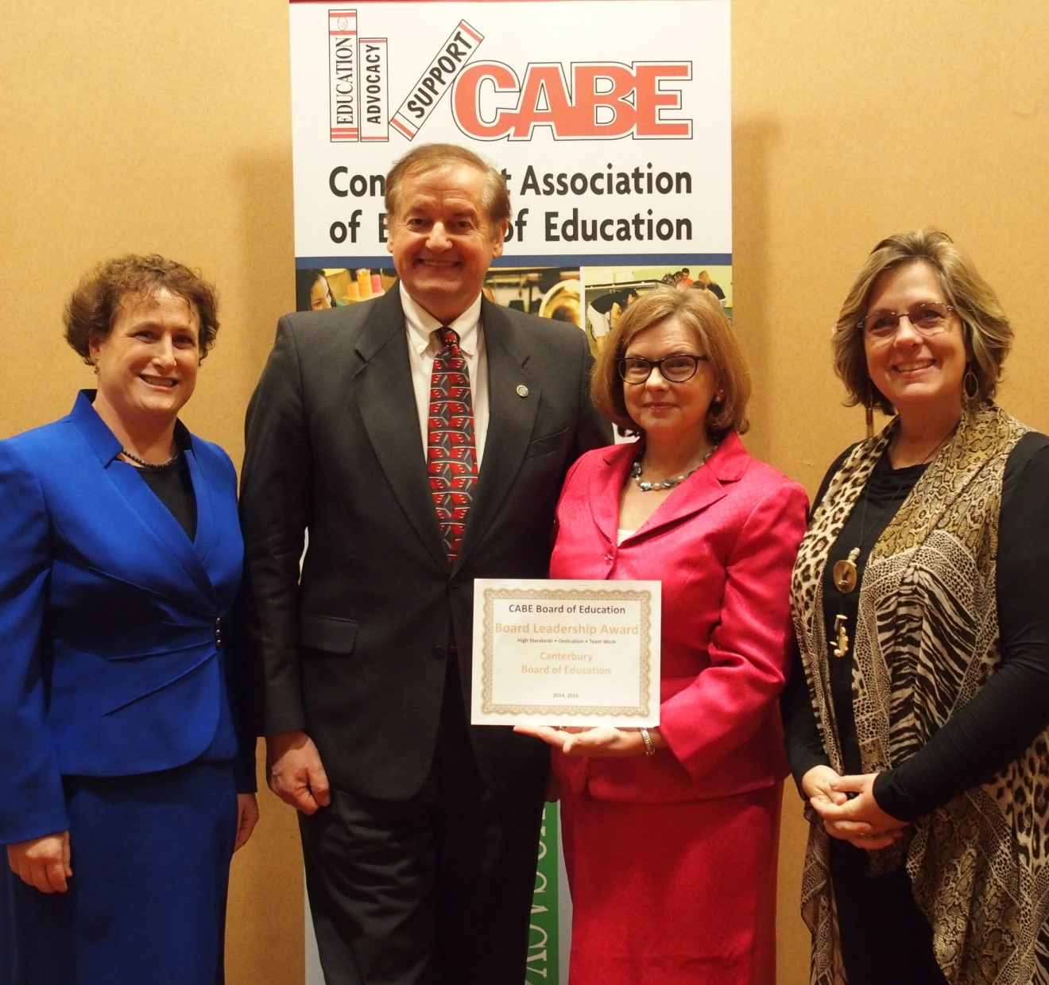
Left to Right: Elaine Whitney (VP of Professional Development for CABE), Walt Petruniw (Canterbury Board of Education Chairperson), Dianna R. Wentzell (Commissioner of Education), Lois DaSilva-Knapton (Superintendent)

In addition, one of our teachers at CES, Sergeant Louise Fletcher, pictured below, is an active National Guardsman and was called away for active duty last school year for an extended amount of time. Canterbury Public School was honored as a 2015 Employer Support Freedom Award Finalist in recognition of exemplary support of National Guard and Reserve Member Employees. Canterbury went above and beyond to support Sergeant Fletcher and her classroom in the her absence. We are so grateful to her and her accomplishments in the National Guard.
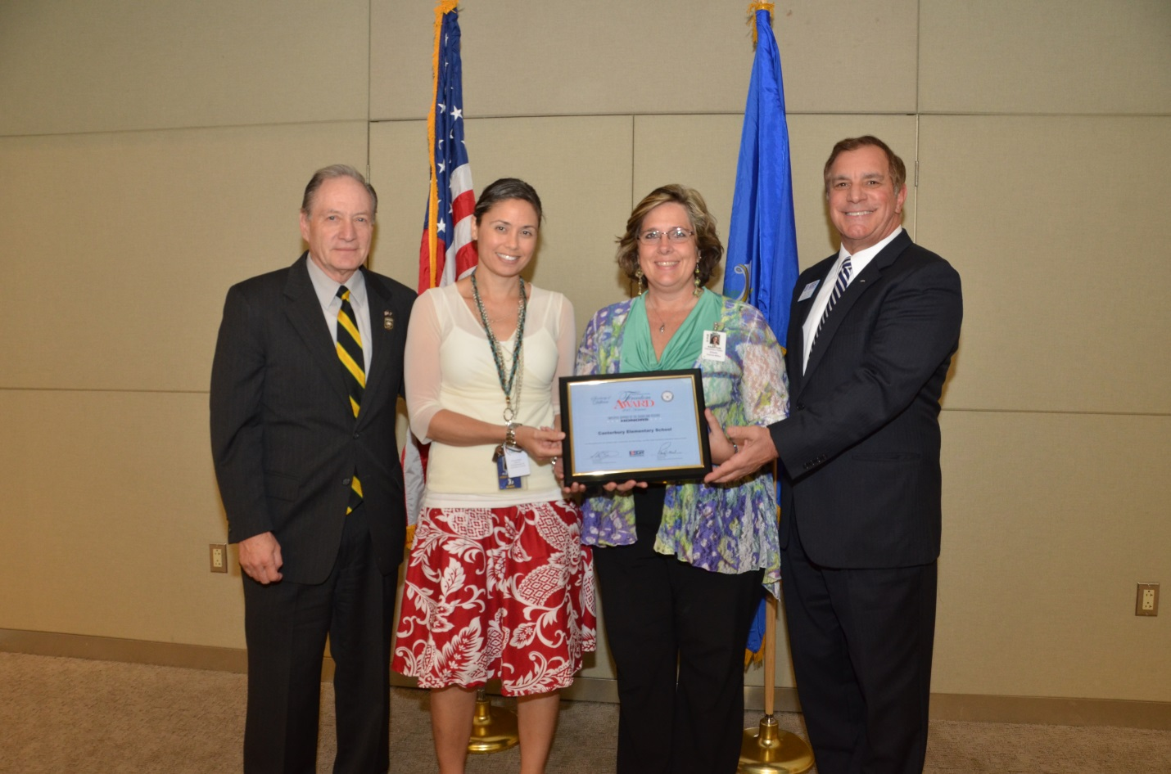
From Left to Right: Principal Deputy, Family and Employer Support Programs, Mr. Alan Baird;
CES 2nd grade teacher Sergeant Louise Fletcher, Superintendent Dr. Lois Knapton,
National Chief of Employer Support of the Guard and Reserve, Mr. Paul E. Mock

I look forward to the months ahead as we continue to provide our students with rigorous academics as well as enrichment activities.
If you read on, you will see that the Principals have described some of the enrichment activities we integrated to enhance the academic experience of Canterbury Public School students.

Canterbury Elementary School, as reported by Principal Sarah Cary:
Picture below represents the 3rd grade Recycling projects at CES
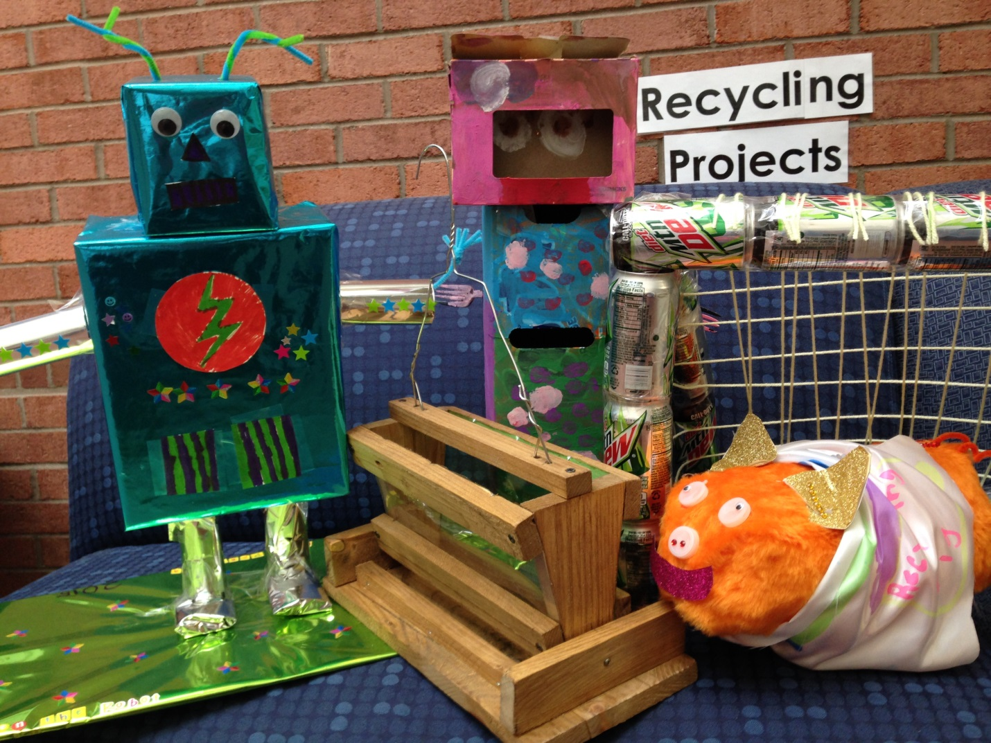
We, at CES, came back to school in the beginning of 2016 ready to learn! Our students continue to make great progress in reading, writing, and mathematics. We participated in many special projects during the first half of the year. For example, the third grade just finished a recycling unit (pictured above) in which the final project was to make something new from recycled objects. They made such things as robots, pencil holders, bird feeders, and stuffed animals. Their projects are on display in our foyer. We continue to have assemblies which recognize our students’ achievements in music, art, and reading. We also honor them for their citizenship and academic excellence. Our faculty is also involved in learning new things as we integrate technology into our classrooms and attend workshops on new trends in physical education, writing, math instruction, and academic needs of young children. Our PTO remains very active and is planning to bring us assemblies and other fun activities, like Field Day, this spring. Our families continue to reach out to us and together we partner to meet the needs of all our children. We are lucky to have such a dedicated staff and community. Thank you to the community for your generosity during the holidays for gifts and boots for those in need. We wish you a healthy and happy new year.

Dr. Helen Baldwin Middle School, as reported by Principal Mr. Ryan Earley
During the first half of the school year the staff and students at BMS have been deeply engaged in learning in various ways. I think it is great that the students in Canterbury have been able to experience learning outside of the classroom that have ranged from the arts to science and technology. Grade 8 students had the Senegal exchange students from Woodstock Academy visit, been able to visit and learn about their high school options, visit Salem MA during the week of Halloween, take a walk down to the Prudence Crandall museum. Grade 7 students spent several days in Wakefield RI at Nature’s Classroom, spent time with an expert on the topic of the Titanic. Grade 6 students took a trip to the USCGA to see a performance of the band as Grade 5 students enjoyed a math Olympics, a Book Barn visit, and various science labs and experiences. The New England Center for Children program also coordinated a wonderful Harvest Luncheon that incorporated cooking, conversation, and the opportunity for students and staff to break bread together to show thanks and support for each other. There have also been several whole school events such as the NFA band, chorus, and dance team perform, the first annual Fall Festival, school talent show, music department Holiday Concert, food drive, a Day of Hope for the victims of the Paris terrorist attacks, and athletically a very successful fall season with the girls soccer team winning their division championship. Canterbury also awarded Jessica Kasecek and Gina Leo with the Superintendent’s Award for 2015 from Grade 8. BMS also sent a team of female students to the statewide summit for Girls in Manufacturing in New London. As the students have been learning and growing, the adults in the school community have been concurrently working diligently on providing more personalized instruction using new assessment tools, creating new fire drill and lock down procedures, and learning about the role that Google Applications for Education can have within the classrooms of BMS. I look forward to sharing more exciting news in the coming months.

